

**Pastor’s Letter**

Dear church folk,

Three of us attended the Vermont Conference Annual Meeting at the end of April. We shared worship, business, workshops and conversation. Our speaker was Rob Voyle, who helped us think about our churches, our conference, and our lives through the lens of Appreciative Inquiry.

Appreciative Inquiry is particularly suited for a church in the interim time, as we learn to ask questions about ways we want to learn to see, to achieve. He also encouraged us to look at the language we use when we envision the present or future. Do we speak in a positive or negative voice? Can we dream of what we would like to see this church become, building on the strengths of the past and present? As Rob said, “Martin Luther King Jr. did not say, “I have a problem”, or “I have a plan.” He said, “I have a dream.”

What is your dream for the Vergennes Congregational Church?

We’ll be spending time this spring asking those kinds of questions and sharing our ideas as the Search Committee grows the profile. Each of you has a part in the life of the church, and we hope you will dream with us.

Friday evening of annual Meeting closed with the following prayer from *Gates of Remembrance:*

*We cannot pray to You, O God, to banish war, for you have filled the world with paths to peace, if only we would take them.*

*We cannot pray to You to end starvation for there is food enough for all, if only we would share it.*

*We cannot merely pray for prejudice to cease, for we might see the good in all that lies before our eyes, if only we would use them.*

*We cannot merely pray ‘Root out Despair’, for the spark of hope already waits within the human heart, for us to fan it into flame.*

*We must not ask of You O God, to take the task that You have given us. We cannot shirk, we cannot flee away, avoiding obligation forever.*

*Therefore, we pray, O God, for wisdom and will, for courage to do and to become, not only to look on with helpless yearning as though we had no strength.*

May it be so.

On the journey with you, *Barbara*

May 5 – Communion Sunday, Deacons Fund collection, spring meeting and luncheon of the Addison Association of the UCC Vermont Conference held in our church starting at 12:30 pm.

May 12 – Mothers Day, Blanket Sunday (see page 3 for details)

May 17, Friday – Our turn to put together a Table of Grace meal. Please contact Alice Maurer (475-2580, [maurer@gmavt.net](mailto:maurer@gmavt.net)) if you can help. Volunteers needed for set up, serve and clean up.

May 19 – The Search Committee will lead a Conversation about the Church and its future during fellowship. (More on page 4). Go! Youth Group, students from 7 to 12, will make cat puzzles for Homeward Bound from 2 to 4. Join the fun!

May 26 –

May 27, Monday – Memorial Day holiday.

May 28, Tuesday – Laundry Love. Volunteers needed for 2 shifts. Please contact Marcia Mazeine (475-2506).

June 4, Tuesday – SAVE the DATE for a memorial party (emphasis party) in honor of Bev Jones, church member extraordinare, on Mount Philo at 4:00 pm. More details to come.

**Mark Your Calendar**

PASTOR’S LETTER---Discovering the Book of Acts

“*When the day of Pentecost had come, they were all together in one place. And suddenly from heaven there came the sound like the rush of a violent wind, and it filled the entire house where they were sitting.”* (Acts 2:1-2 – NRSV)

The book of Acts is often called the “Acts of the Apostles,” but it may be more accurate to consider the book as titled: “The Acts of the Holy Spirit.” The author of Luke wrote two books that were included in our canon. The second book is – Acts. It shares the story of the followers of Jesus, inspired by His Spirit, translating His words and stories into the world around them – forming themselves into communities of faith.

Beginning Sunday March 5th the Church is offering a Lenten study of the first 6 chapters of the Book of Acts, which focus on the very beginnings of a growing faith set in Jerusalem. Subsequent chapters will focus on the movement beyond Jerusalem and even into non-Jewish territories. It will be interesting to see if our readings of these ancient texts can lead to some insight about how we operate as a body and how the Holy Spirit may be at work in us here and now, some 2000 years later.

In the last two generations, since the mid-twentieth century, much has changed in our society and in the role of the church. Christianity no longer enjoys the kind of taken-for-granted support that it once did. Today American society is secular, religiously pluralistic, and ethnically diverse. In many ways, *it reflects the world of the Acts of the Apostles*, a world where Christianity was not socially sanctioned nor mandated by the government. Christians were a minority, and the church was more of a mission movement than an established social institution. As we negotiate these changes in our social role, Acts will be helpful to us.

The Deacons have purchased workbooks to help us prepare before each gathering. The first meeting (March 5th after worship – in the Manse) will cover chapter 1. I will send out emails to the church letting everyone know what we will be studying and offering ideas for preparation, so you need not have a workbook in order to join in.

In preparation for this Sunday and Sundays following, the workbook suggests:

“Find a comfortable place to sit, when you can be undisturbed for 15 minutes of so. Read the text slowly, prayerfully and meditatively. Savor the words. Put yourself into the text with your senses. … Pay attention to the words or phrases that speak to you or jump out at you.” Then read the passage a second time – maybe not in the same sitting. As you read it again, note any questions or any thoughts that surface as you read. Jot down notes or underline passages.

We will share our thoughts and insights with each other. Through these **discussions of discovery,** I hope and expect that the Holy Spirit will fill the room with its presence as we learn and grow together.

Peace to you all,

Gary

Easter

Easter Sunday, April 21, dawned with the annual sunrise service on Comfort Hill. That was followed by a breakfast in Fellowship Hall of pancakes, sausage and fruit organized by Mike O’Daniel, pancake king, and his kitchen crew. Thanks to all! A joy filled celebration of the Resurrection in the Sanctuary included music by the choir, the congregation, and of course Jenny, who topped off the service with an inspiring toccata. Wow! The cross was covered in flowers by everyone and carried outside to bless the day for all passersby. And the weather could not have been better too.

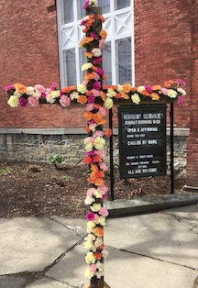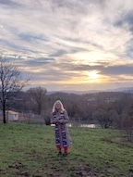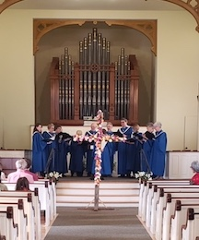

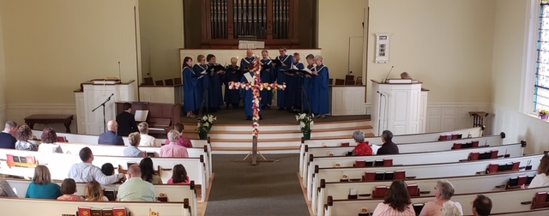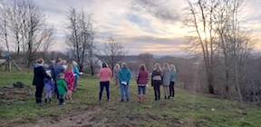

**Greening up the Church**  
  
Thanks to volunteers from the high school and Evergreen on May 2nd, the church is spic and span inside and out. Paul Vachon and Sue O’Daniel were on hand as coordinators and inspirers. Take a look at one huge change – the grape vines planted to commemorate Gary’s sabbatical are gone from the grass divide by the Food Shelf. They were replanted closer to the playground for preschoolers to watch nature in action. Much appreciation to all who wielded vacuums, mops, shovels, and wheelbarrows – What a gift to us all!

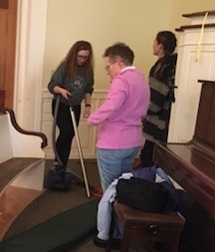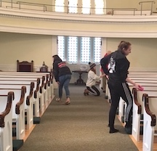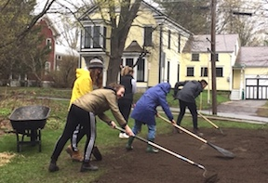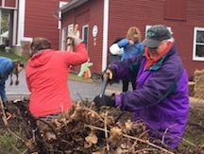

**Earth Day and Easter Eggs**

On Saturday April 20 a new twist was added to the usual Easter Egg hunt thanks to the creativity of Abigail and her assistants. Posters and ads went out for an Earth Day Fair and egg hunt on the City Green from 9 to 11am. Unfortunately, due to rainy weather activities were moved into Fellowship Hall, but that didn’t dampen the enthusiasm of budding artists. Anyone from the community was invited to build a bug house or seed bomb, paint with ecco paint, make a bird feeder and of course hunt for Easter eggs.  Thank you to everyone who helped make this new event a success!

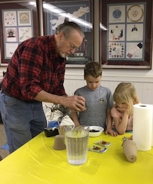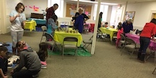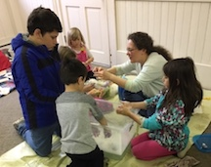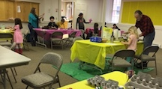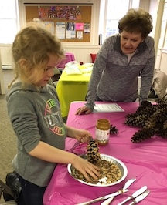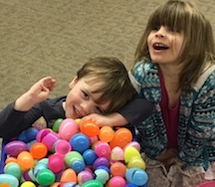Abigail Diehl-Noble, Christian education coordinator

**Blankets of Love**

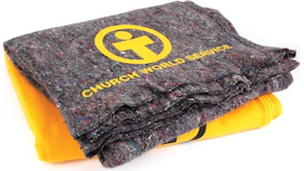This Mothers Day, May 12, the Mission Committee invites you to blanket the world with Love. In 2018 Church World Service distributed 1000s of blankets around the world, including dozens in the US after hurricanes, floods and tornadoes. Please help give comfort to families fleeing their homes, recovering from disaster and more.  Honor a mother you know by participating in our Blanket Sunday Church World Service offering on May 12. A $10 donation buys one blanket. Please make checks out to CWS/Blankets. Thank you!

Mission Committee: Marcia Mazeine, Chair, Mary Ann Castimore, Alice Maurer, Jeanne Peters, Susan Schaefer, Mel Simmons and Helen Myhre.

***We are a vibrant, Christian community – full of life, music and laughter.  We gather to worship and to explore and grow our faith.  We embrace everyone, wherever they are on life’s journey.  We strive to love and serve with compassion and grace – as Jesus did – to make a difference in our community and beyond.***

Search Committee Seeks Comments

The Search Committee has been meeting with Pastor Barbara every other week to work on the church profile to be submitted to the Vermont Conference. We are gathering information about who we are as a congregation and community and **are asking for your participation.**  A series of questions went out to everyone on the church email list and was also included in an insert in the Sunday bulletin. A second series of questions will go out a bit later in May, and we hope everyone will share thoughts, feelings and ideas for the profile. We will also host two small group sessions after worship on May 19 and June 9 and would like representation from as many of you as possible.

During this time the Committee is also reaching out to our Deacons, Trustees, Mission Committee, Executive Committee, Christian Ed Coordinator and Treasurer for their input and knowledge.

We are working in a timely manner to complete the profile, but acknowledge the need to describe our congregation on more than a surface level to attract applicants who truly connect with all of us. This takes time and reflection.

In case you missed the first series of questions, please answer and get back to us.

1. Describe several strengths or positive qualities of our congregation.
2. 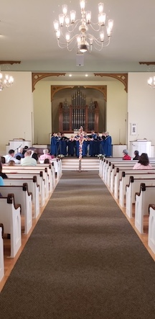Describe what you value about living in our area.
3. What else would you like to share with the Search Committee?

You can bring responses to church, mail them to 30 South Water Street, Vergennes 05491 or email them to [vucc@vergennesucc.org](mailto:vucc@vergennesucc.org)

We hope to hear from everyone! Thank you for taking time to share your thoughts and ideas.

VCC Search Committee: Karen Beinhaur, Jenny Bower, Sharon O’Daniel, Jim Ouimette, Jane Spencer, Dave Tatlock

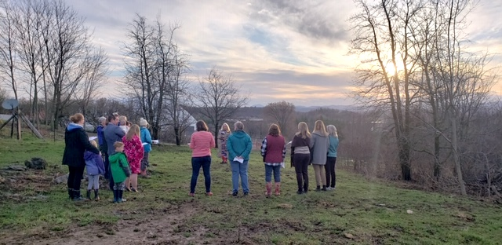

*The Congregational Church of Vergennes, United Church of Christ, is an Open and Affirming Christian Community seeking to be a place of sanctuary, healing, inclusion, challenge and compassion.*

Your editors, **Alice Maurer** and **Jeanne Peters,** welcome all suggestions for the newsletter. Content is due by the **25th** of each month and everyone has a chance to comment on their copy before publication. Thank you all for past and future help.