

**Pastor’s Letter – Changes**

Dear Church Family,

The seasons change. Autumn reminds us of the cycle of the year when we look for the beauty of turning leaves, knowing that they will soon let go to nourish the earth and future growth. We give thanks for summer’s activity and look to the harvest, to different ways to gather and grow.

Your season of preparation has been steady and fruitful, and as the Search Committee celebrates the Profile’s posting on UCC National Ministry Opportunities, they will begin an exciting new step in their work (see details page ???).

And this is some of what the new pastor will be joining – the flow of life here at Vergennes Congregational and the many ways this church lives out the call to be God’s people.

* Laundry Love volunteers coming in to collect supplies
* Kitchen angels making coffee and snacks
* Sunday school teachers assembling class materials
* Food Shelf patrons gathering every other day for needed supplies
* Mike answering the phone and responding to requests for help
* Fine tuning the bulletin and sound system and being the go-to person for many questions
* The choir voices echoing from the Manse on Sunday morning
* Deacons setting up for worship
* Prayer requests and joys shared in worship
* Committed committees meeting monthly (or more if you’re on the Search Committee)
* Communion bread bakers and reception cookie makers
* Trustees overseeing new stoves and fixing things
* Children trying to sit still for a children’s moment
* The peace at the end of the service as we listen to the Postlude
* Playgroup parents enjoying community and the energy of young children in the hall
* Community groups meeting here in the evenings
* A church of community and for community
* And so much more….

I am honored to share this interim time with you,

Barbara

October 6 – Worldwide Communion Sunday, Neighbors in Need giving (See details page 3), CROP Walk right after worship (see details page 2).

October 13, Sunday – Addison Association meeting at New Haven Congregational Church from 12:30 to 3:00 pm. Anyone is invited to see Abigail Diehl-Noble commissioned as a Licensed Pastor (congratulations Abigail). Bottle collection to help refurbish Sunday School rooms.

October 14, Monday – Columbus Day

October 20 – Potluck lunch after worship organized by the Deacons. Look for details in coming bulletins. Bottle collection.

October 22, Tuesday – volunteers needed for Laundry Love. Contact Marcia Mazeine (475-2506).

October 29, Sunday – Daylight Savings Time begins (turn clocks back an hour).

October 31, Tuesday – Happy Halloween!

**Mark Your Calendar**

PASTOR’S LETTER---Discovering the Book of Acts

“*When the day of Pentecost had come, they were all together in one place. And suddenly from heaven there came the sound like the rush of a violent wind, and it filled the entire house where they were sitting.”* (Acts 2:1-2 – NRSV)

The book of Acts is often called the “Acts of the Apostles,” but it may be more accurate to consider the book as titled: “The Acts of the Holy Spirit.” The author of Luke wrote two books that were included in our canon. The second book is – Acts. It shares the story of the followers of Jesus, inspired by His Spirit, translating His words and stories into the world around them – forming themselves into communities of faith.

Beginning Sunday March 5th the Church is offering a Lenten study of the first 6 chapters of the Book of Acts, which focus on the very beginnings of a growing faith set in Jerusalem. Subsequent chapters will focus on the movement beyond Jerusalem and even into non-Jewish territories. It will be interesting to see if our readings of these ancient texts can lead to some insight about how we operate as a body and how the Holy Spirit may be at work in us here and now, some 2000 years later.

In the last two generations, since the mid-twentieth century, much has changed in our society and in the role of the church. Christianity no longer enjoys the kind of taken-for-granted support that it once did. Today American society is secular, religiously pluralistic, and ethnically diverse. In many ways, *it reflects the world of the Acts of the Apostles*, a world where Christianity was not socially sanctioned nor mandated by the government. Christians were a minority, and the church was more of a mission movement than an established social institution. As we negotiate these changes in our social role, Acts will be helpful to us.

The Deacons have purchased workbooks to help us prepare before each gathering. The first meeting (March 5th after worship – in the Manse) will cover chapter 1. I will send out emails to the church letting everyone know what we will be studying and offering ideas for preparation, so you need not have a workbook in order to join in.

In preparation for this Sunday and Sundays following, the workbook suggests:

“Find a comfortable place to sit, when you can be undisturbed for 15 minutes of so. Read the text slowly, prayerfully and meditatively. Savor the words. Put yourself into the text with your senses. … Pay attention to the words or phrases that speak to you or jump out at you.” Then read the passage a second time – maybe not in the same sitting. As you read it again, note any questions or any thoughts that surface as you read. Jot down notes or underline passages.

We will share our thoughts and insights with each other. Through these **discussions of discovery,** I hope and expect that the Holy Spirit will fill the room with its presence as we learn and grow together.

Peace to you all,

Gary

**Children’s Ministry**

**Welcome** to **Marybeth Partington**, who was recently hired as our Coordinator for Children and Families. Many of you know Marybeth, who grew up in this church and has many good ideas for our future ministries. And thanks to the Faith Formation Committee who worked hard to find the right person to fill this position.

From Marybeth:

I am excited to be working with our youth and families. We have a great curriculum this year that follows the lectionary for the sermons. There is a wonderful group of volunteers who help teach and guide our youth on Sunday mornings (**more volunteers** **are always welcome!**). Over the next few weeks we will be doing a **bottle drive** to raise funds to update the Sunday School spaces. Please save your bottles.

Thank you!

Marybeth, Coordinator for Children and Families

**CROP Hunger Walk to be held Oct. 6**

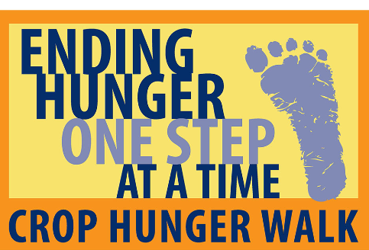October 6 will mark the forty-second year that Addison County volunteers have walked to raise money to fight hunger and poverty through the annual CROP Hunger Walk.

Walkers will gather on the Middlebury town green between noon and 12:45 p.m. The route is on sidewalks through town (Court Street to Buttolph Acres to Main Street to Middlebury College campus and back down Main Street to the town green). Walkers can join in for any part of the route, or complete the entire walk. **Sign up with a Mission Committee member in Fellowship Hall.**

**Neighbors in Need**

 On Sunday, October 6, the Church bulletins will be filled with envelopes for one of the UCCs important giving causes. Neighbors in Need (NIN) supports the UCC’s ministries of justice and compassion throughout the United States. Two-thirds of the offering is used by the UCC’s Justice and Witness Ministries to fund advocacy work on issues such as **voting rights, immigration, health care, hate crimes, civil liberties, and environmental justice.** NIN also supports American Indian needs in 20 UCC congregations on reservations and one urban, multi-tribal UCC congregation in Minneapolis, Minnesota. Contributions can be made online or by check to VCC with Neighbors in Need in the memo line.

**Trustees Highlights**

Stove update: The new Church gas stoves and the venting system are now functioning, but the kitchen work is not completely finished.  A new window is on order and needs to be installed and painting should be done. Both stoves have been "self cleaned" to remove factory residue in the ovens and the exhaust hoods have been tested.

Other news:

* Approved hiring **Marybeth Partington** as Coordinator for Children and Family Ministries, effective immediately  
* Established 2019 Stewardship team of **Amy Masback,** **Paul Vachon**, and **Rev. Barbara Purinton**; speakers planned and Luncheon scheduled for Nov. 17  
* Approved replacing keys to all Church and Manse doors following the recent loss of Mike's "ring of labeled keys" ; all doors will be re-keyed   
* Approved going forward with Mission Concert 2019 and seeking volunteer coordinator team members  
  
Trustees: Chair Paul Vachon, Bob Cobb, Joanne Dion, Kitty Oxholm, Phil Bourgeois, Jim Ouimette

*The Congregational Church of Vergennes, United Church of Christ, is an Open and Affirming Christian Community seeking to be a place of sanctuary, healing, inclusion, challenge and compassion.*

**Food for Fuel**

In spite of threats of rain and 20 mph wind gusts, September 14 saw the City Green buzzing with community for the 6th annual Food for Fuel and More event. Starting at 9:00 am volunteers gathered to move 7 tables and 36 chairs from Church to Green. **Bill Hopkins** and his Lions Club crew set up 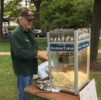the grill for hamburgers and hot dogs. They also brought the Lions’ popcorn machine, a welcome addition to a chilly day. All the goodwill, cookie making, heft and veggie slicing is so appreciated. To add to the fun, Basin Harbor once again loaned their Champ Bouncy House and kept the kids warm jumping. We sold 65 mums from **Bill Scott** (thank you Bill), netting almost $300 and made friends with passersby – one couple from Ottawa. The net was $1357.54 out of a total $1900. Again, thank you to all the helping hands – it takes dozens and much Church spirit to put this event together and add dollars to our important Mission fund.

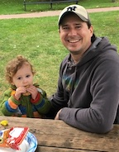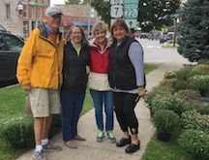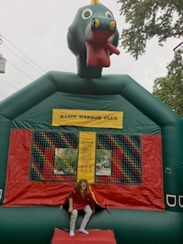

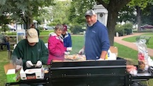

***We are a vibrant, Christian community – full of life, music and laughter.  We gather to worship and to explore and grow our faith.  We embrace everyone, wherever they are on life’s journey.  We strive to love and serve with compassion and grace – as Jesus did – to make a difference in our community and beyond.***

**Sunday, September 29,**the Deacons led a hike at the Waterworks area on Plank Road heading toward Bristol.  Everyone enjoyed the loop around the pond and bagged lunches along the way.

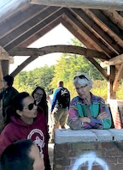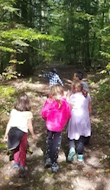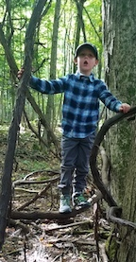

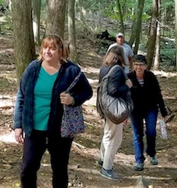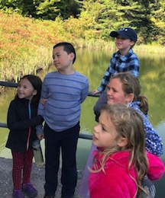

**Search Committee Update**

The Search Committee met with **Rev. Lynn Bujnak**, the Vermont Conference Minister, after worship on Sunday, September 22. We reviewed Lynn’s feedback on our Church Profile and heard more about what we can expect as next steps. **NEWS – Our profile was officially submitted this week, and it has already been placed on the national UCC website.** Now that the profile is online, Lynn expects there will be a lot of immediate interest expressed by qualified candidates. The profile (a detailed description of our Church) is strong and even though there are many Vermont churches seeking pastors, the majority are looking for part-time rather than full-time ministers. As we receive the applicant profiles, probably three at a time, we will read them thoroughly, eliminate some and move forward with others. Moving forward involves listening to candidates’ sermons online, checking references, holding interviews (and possibly experiencing live preaching if that can be arranged nearby.) It is a process of getting to know one another until we narrow down the candidate who we want to present to the congregation. We will do our best to keep the congregation informed as we continue on this very important journey and ask, once again, for your prayers of support and encouragement. We also thank everyone who has shared ideas and concerns.

Search Committee

Karen Beinhaur, Jenny Bower, Sharon O’Daniel, Jim Ouimette, Barbara Purinton, Jane Spencer, Dave Tatlock

**Seeking Nursery Caregiver**

One of our wonderful nursery staff is moving on at the end of September.  Thank you, Laura, for your care of the children!

Please pass this note on to those you might know:

Vergennes Congregational Church, a warm, progressive Christian community, seeks a nursery teacher on Sunday mornings from 9-11 a.m. The position starts at $15/hour. We seek a loving, experienced caregiver to be with our youngest children ages 0-3. For more information, please contact Children's Ministry Coordinator Marybeth Partington at 802-877-2453 or [marybeth@vergennesucc.org](mailto:marybeth@vergennesucc.org), or Rev. Barbara Purinton [pastor@vergennesucc.org](mailto:pastor@vergennesucc.org)

Your editors, **Alice Maurer** and **Jeanne Peters,** welcome all suggestions for the newsletter. Content is due by the **25th** of each month and everyone has a chance to comment on their copy before publication. Thank you all for past and future help.