

**PASTOR’S LETTER – Time of Life and Love**

Some years ago, in an IKEA ad, a group of children were asked to write a letter to the Three Kings and describe what they wanted for Christmas. They listed toys of all kinds. Then they were given another piece of paper and asked to write a letter to their parents, telling them what they wanted for Christmas. The children thought a bit, and then each wrote another letter. The parents, reading these letters, learned that the children wanted more time with them – a day together, an evening home, time to play soccer or read a book. When asked which letter they would send, the one to the Three Kings, or the one to their parents, the children again thought. “That is a difficult question,” one said, and then each, and all, responded, **“The one to my parents.”**

I recall a Christmas Eve a couple of years ago. After the church service, the power went out all over the town of Bakersfield, where I was serving as interim. I learned later that the Christmas videos and other planned events were replaced by a fire in the stove and reading the Christmas story together as a family. And people remember that as one of the best Christmas Eves ever.

These last months of the year often bring a myriad of activities – school concerts and plays, craft fairs, cookie baking, carol sings, and the ever-present list of things to get and things to do as the holidays approach. Add to that the challenges many have faced this year with illnesses or the loss of loved ones. The season can be difficult as we anticipate a different Christmas. But isn’t this the world that God chose to enter? A world, unsettled and worried and hoping for God to do a new thing?

And that new thing was Presence. God in human form, come close. A baby, a child, a Holy Love that reminds us still that whatever path we walk, we have footsteps to follow. We know that whatever we experience, Jesus has been there and is here, now. God with us.

May the weeks of Advent bring new hope. May you find good time to spend with others – children or grandchildren, parents or grandparents, neighbors who might need an invitation to come sit by the fire or join in an Advent worship service. The gift of time shared is irreplaceable.

Take time to be with God, too – the holiday season began as a recognition of God’s presence and care for God’s people. You are warmly invited to gather together in worship as we pause to remember the One who is Time and Life and Love.

Faithfully, ***Barbara***

Note: The Calendar is a bit late, but you can always contribute to the Deacons Fund. Thank you to those who helped cut and haul the Christmas tree on Dec. 1 and decorate the Sanctuary on Dec. 5th.

December 7, Saturday – Vergennes Christmas Stroll. Many activities throughout the day, including a craft fair at the high school that benefits the Food Shelf and Maiden Vermont singing at the Library.

December 8, 2nd Sunday of Advent –Last chance to select a gift from the Giving Tree (see details page 2).

Second Sunday of 5 week Advent Study – Pausing on the Road to Bethlehem (see details page 2).

Sign up for poinsettias to decorate the Sanctuary on Christmas Sunday. Contact **Denise Martin**for details (453-3349).

Don’t forget the **Mission Concert at 2 pm**! Come support the many needs of our community while enjoying all types of music, generously donated by gifted people from around the state.

December 15, 3rd Sunday of Advent –The Christmas Pageant during worship.

December 21, Saturday – Longest Night service at 4 pm. Join in a time of reflection and healing.

December 22, Christmas Sunday and 4th Sunday of Advent – Christmas offering for Veterans of the Cross (see details page 3)

December 24, Christmas Eve – 2 services:

4:00 p.m. –  Marionette Service for children and adults.

7:00 p.m. – Traditional Candle Light Service. Celebrate Christ’s birth in a Sanctuary filled with music and light. Last Advent candle lighting. **Take home poinsettias** after the service.

December 25, Wednesday –Christmas Day. No worship service.

December 29, Sunday – Last Sunday before the New Year.

January 26, Sunday – Annual Meeting after worship service.

**No Newsletter in January, but look for the Annual Report.**

**Mark Your Calendar**

PASTOR’S LETTER---Discovering the Book of Acts

“*When the day of Pentecost had come, they were all together in one place. And suddenly from heaven there came the sound like the rush of a violent wind, and it filled the entire house where they were sitting.”* (Acts 2:1-2 – NRSV)

The book of Acts is often called the “Acts of the Apostles,” but it may be more accurate to consider the book as titled: “The Acts of the Holy Spirit.” The author of Luke wrote two books that were included in our canon. The second book is – Acts. It shares the story of the followers of Jesus, inspired by His Spirit, translating His words and stories into the world around them – forming themselves into communities of faith.

Beginning Sunday March 5th the Church is offering a Lenten study of the first 6 chapters of the Book of Acts, which focus on the very beginnings of a growing faith set in Jerusalem. Subsequent chapters will focus on the movement beyond Jerusalem and even into non-Jewish territories. It will be interesting to see if our readings of these ancient texts can lead to some insight about how we operate as a body and how the Holy Spirit may be at work in us here and now, some 2000 years later.

In the last two generations, since the mid-twentieth century, much has changed in our society and in the role of the church. Christianity no longer enjoys the kind of taken-for-granted support that it once did. Today American society is secular, religiously pluralistic, and ethnically diverse. In many ways, *it reflects the world of the Acts of the Apostles*, a world where Christianity was not socially sanctioned nor mandated by the government. Christians were a minority, and the church was more of a mission movement than an established social institution. As we negotiate these changes in our social role, Acts will be helpful to us.

The Deacons have purchased workbooks to help us prepare before each gathering. The first meeting (March 5th after worship – in the Manse) will cover chapter 1. I will send out emails to the church letting everyone know what we will be studying and offering ideas for preparation, so you need not have a workbook in order to join in.

In preparation for this Sunday and Sundays following, the workbook suggests:

“Find a comfortable place to sit, when you can be undisturbed for 15 minutes of so. Read the text slowly, prayerfully and meditatively. Savor the words. Put yourself into the text with your senses. … Pay attention to the words or phrases that speak to you or jump out at you.” Then read the passage a second time – maybe not in the same sitting. As you read it again, note any questions or any thoughts that surface as you read. Jot down notes or underline passages.

We will share our thoughts and insights with each other. Through these **discussions of discovery,** I hope and expect that the Holy Spirit will fill the room with its presence as we learn and grow together.

Peace to you all,

Gary

**Join in a Spiritual Journey Through Advent**

As it does every year, Advent comes upon us much too quickly, and we get caught up in the whirlwind of activities and preparations that lead to Christmas. It will be January before we know what hit us. We will have rushed through another Advent, hardly stopping to take a breath and wonder at the good news of Emmanuel, "God with us."

This study – Pausing on the Road to Bethlehem – is designed for those who want to slow down and sink into the Advent season. During five sessions we will utilize music, art, poetry, and a variety of interactive activities centered on biblical passages that connect to Advent.

Join us after worship Sundays in December. A one session New Year study will follow.

**Christian Education**

We have a busy month ahead! I want to thank all my volunteers who have helped teach over the past couple of months! We are lucky to have some amazing dedicated volunteers. If anyone would like to volunteer to help teach Sunday School, we need more people before we can split the group into two more age appropriate classes. Please contact me at marybeth@vergennesucc.org.

This year our Christmas Pageant will be on the 15th, and the kids have been working hard! Come join us for the results. Also, Mel Simmons has graciously agreed to allow us to use his hand made marionettes again for the Christmas Eve service at 4pm. On the 22nd and 29th, we will replace regular Sunday School with interesting activities. I look forward to seeing you all throughout this season.

Marybeth Partington

Youth and Family Coordinator

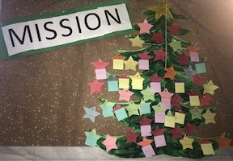**The Giving Tree**

The Mission Committee's annual Giving Tree was installed Dec 1 on the bulletin board in Fellowship Hall.  On it are 40 gift wishes to bring joy to children and adults in our community on Christmas.  Take a look – there are still gift wishes to be selected from the tree.

Please bring any gifts you chose back to the Church, wrapped, and with the sticky note of the gift you selected attached to the package by Sunday, December 15.  Thank you!!!

Mission Committee: Marcia Mazeine, Chair, Mary Ann Castimore, Alice Maurer, Jeanne Peters, Susan Schaefer, Mel Simmons

*The Congregational Church of Vergennes, United Church of Christ, is an Open and Affirming Christian Community seeking to be a place of sanctuary, healing, inclusion, challenge and compassion.*

**Treasurer Update – Still Time to Pledge**

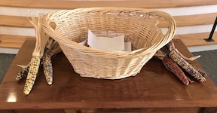Church pledges are slowly coming in. As of December 1st, pledges totaled **$103,614** from 39 pledging units**. Last year at this time**, pledges totaled **$115,180** from 56 pledging units, a difference of more than $11,000. The Trustees will begin building a budget based on the pledges received. **It is not too late to submit your pledge.**  You can fill out an “estimate of giving” card and put it in the collection plate, mail it to the Church labeled Attn: Treasurer or email me at KLBarrett@gmavt.net. The Trustees will finalize the budget at their meeting in early January.

Giving is easy. There are several payment options:

*The collection plate.

* Mail the pledge payment to the Church.

*Pay through Vanco and you can control the frequency and timing of your payments. Through Vanco you can use your credit card to make payments. (The Church cannot take credit card payments directly.) Please contact me if you need help setting this up.

*Gift appreciated stock to the Church by asking your broker to call Bristol Financial Services for the required information to make the transfer to the Church’s Endowment account. (Once you have done that, please let me know to be on the lookout for the transfer. )

* For those who are older than 70 ½ and have a retirement account with required yearly withdrawals, you can ask the custodian of your account to send the withdrawal check directly to the Church. Ask your accountant for his/her advice if it is possible to set that up through an IRA. It could be a way of saving money on taxes.

Thank you for all your support of the Church with your time, talents and dollars.

God Bless,

Kathy Barrett, Treasurer

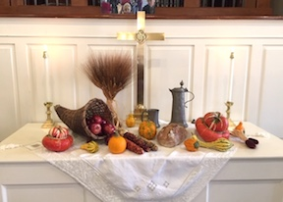**Search Committee Interviewing**

The Search Committee met several times in November and plans to meet several times in December. We continue to carefully read applicant profiles as they arrive and have begun the interview process with candidates. So far, applicants tend to vary in ability and interest. We are doing our best to thoughtfully match our church to a candidate who will best help us meet our challenges. Please continue to keep us in your prayers.

Search Committee: Karen Beinhaur, Jenny Bower, Sharon O’Daniel, Jim Ouimette, Jane Spencer, Dave Tatlock

**Retired Pastors Need Remembering, Too**

***We are a vibrant, Christian community – full of life, music and laughter.  We gather to worship and to explore and grow our faith.  We embrace everyone, wherever they are on life’s journey.  We strive to love and serve with compassion and grace – as Jesus did – to make a difference in our community and beyond.***

For over 100 years, **the Christmas Fund for the Veterans of the Cross** and the Emergency Fund has been a way to ensure that a light of love and hope will always shine for the UCC faithful servants who find themselves facing unforeseen financial need. The generosity of many churches and individuals has helped provide Pension Supplementation, Health Premium Supplementation, special grants for emergencies, and Christmas “Thank You” Gift Checks to over 1,000 individuals and families in need. This year’s Christmas Fund offering is **December 22, 2019**. On behalf of the hundreds of UCC clergy and lay employees and their families whose lives have been touched by your support of last year’s Christmas Fund Offering, sincere thanks for your generosity!

**Food**

Preparing and giving (and eating) food was a November theme. It began with spaghetti and a movie night on Saturday, November 16. Children danced to the movie “High School Musical.”

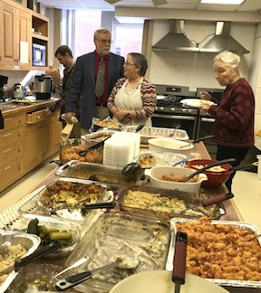The next morning Fellowship Hall was filled with potluck diners on Celebration Sunday, honoring Stewardship pledging. What a feast, organized by **Shirley Andrews** and delivered by **Randy** and **Betty Hawkins.** Once again **Joaninha Kitoko** was incleanup mode**.** Bountiful thanks to you all !! The cooking skills of our church community were on display in countless casseroles, salads and ham topped off by a delicious cake. Yum! This was the first test of our new stoves, symbolic of everyone’s giving spirit that keeps our Church going and celebrating God.

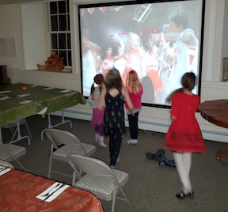

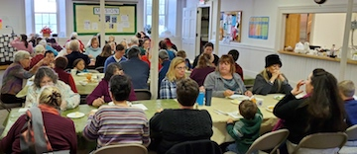

**Table of Grace – Reaching Out with Dinner**

The Table of Grace free dinner was relaunched November 22, with our church in charge. It had been put on hold for almost a year. The menu: meatloaf, mashed potatoes, mixed veggies, rolls, dessert, and a lot of goodwill. Volunteers, organized by **Alice Maurer**, arrived at 2:30 to start the cooking. More volunteers set up tables, served and helped cleanup. Special thanks goes to **Joaninha Kitoko** and **Amy Masbeck** for staying from start to finish at 7:00 pm. Strong armed **Skip** was handy to have around, too. Thirty-five people enjoyed the meal in Fellowship Hall and another 35 take-out meals were provided. **Thank you all!!**

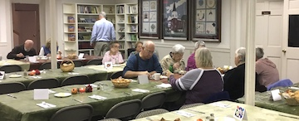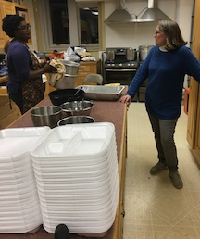

Your editors, **Alice Maurer** and **Jeanne Peters,** welcome all suggestions for the newsletter. Content is due by the **25th** of each month and everyone has a chance to comment on their copy before publication. Thank you all for past and future help. NO NEWSLETTER IN JANUARY. Watch for the annual report.